The three videos provided do provide some very valuable tips. I am especially fond of the second video with the app suggestions. However, I already have a system that works quite well for me. The methodologies I administer for online learning are as follows:

1. Organization: *plan ahead filestructure screenshots*
2. Preparation: *read through unit on first day chrome tabs*
3. Prioritization: *organize chrome tabs details on methodology for execution*
4. Motivation: *gamify taskmaster*
5. Distractions: *adult pressure alone selfmotivation one shot self paying for exams in file* *names see concentration personality focus intently hours on end until task finished dislike interruptions so work till done submissions early done when done*
6. Workspace: *blanket tea water vape pens books pics*
7. Concentration: *music noise cancelling headphones with pic fav songs linked* *Bluetooth charged training share program lounge pic draw.io for interaction of handbook materials*

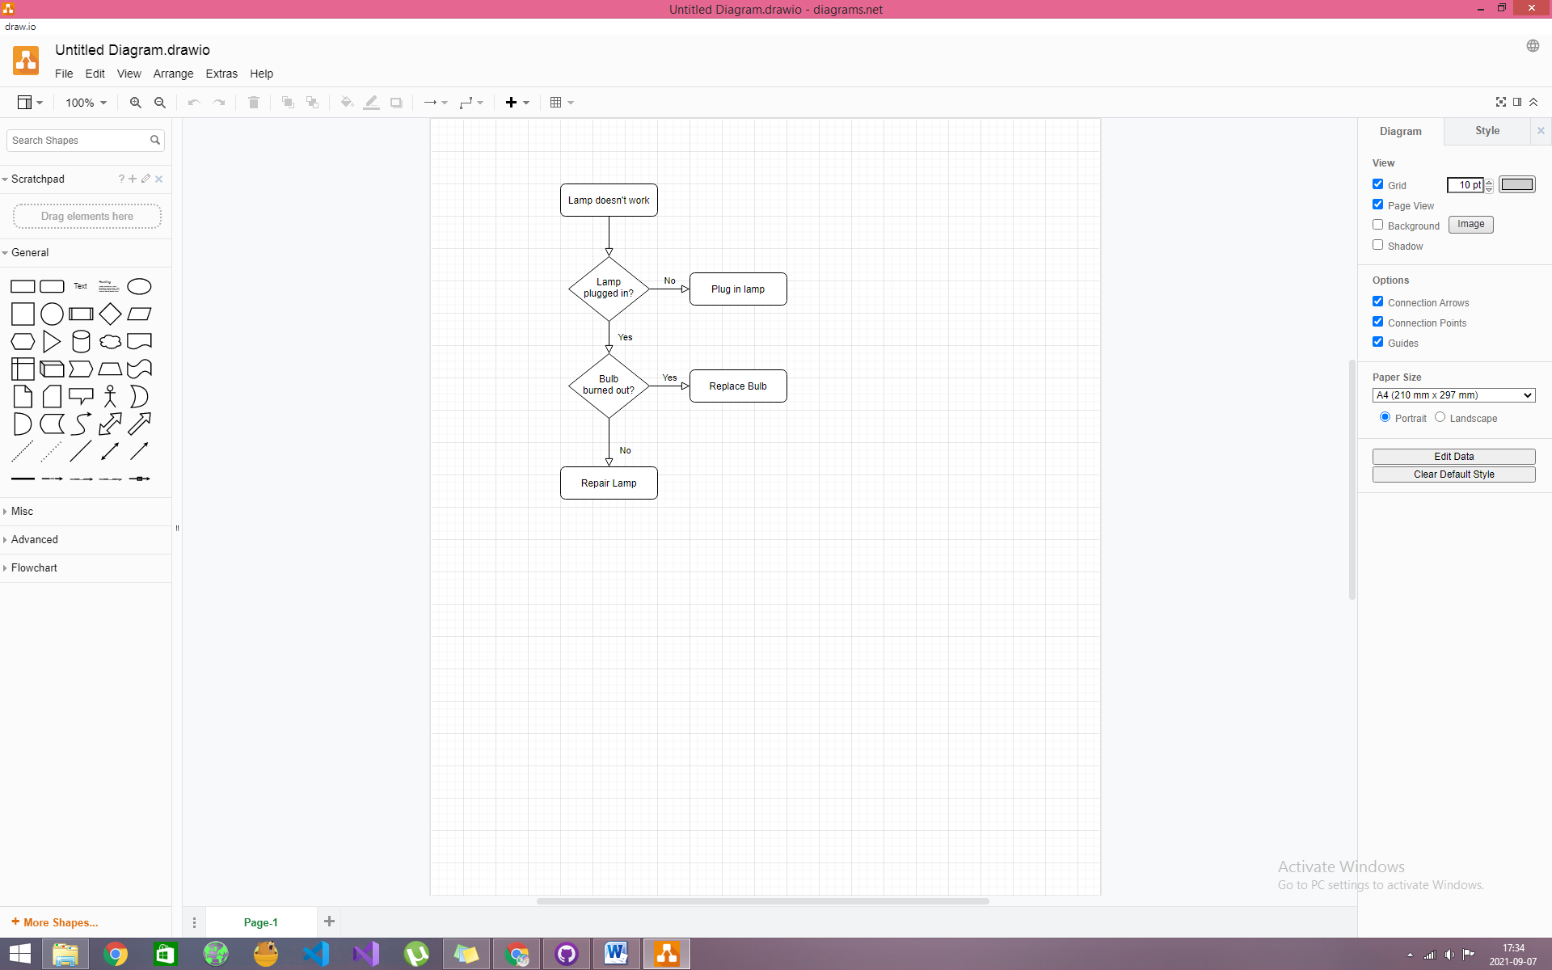

1. Thoroughness: *files with instructions double check*

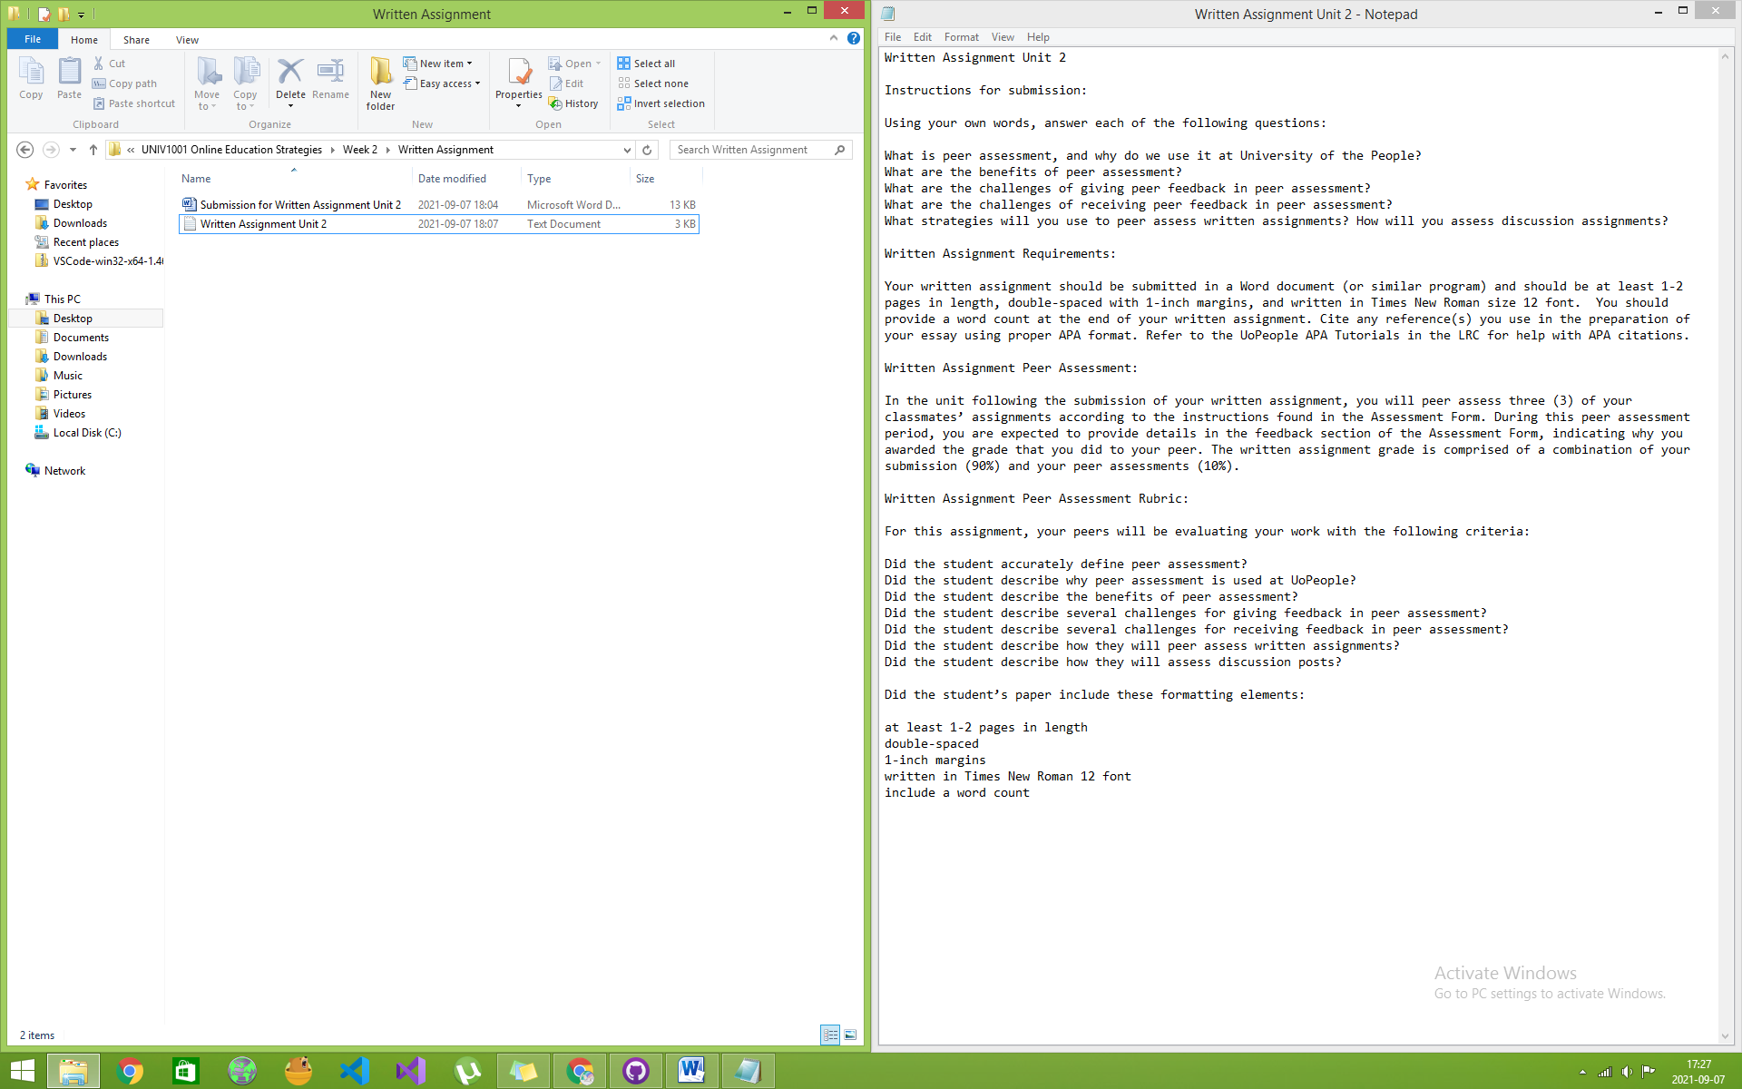

1. Backups: *git*

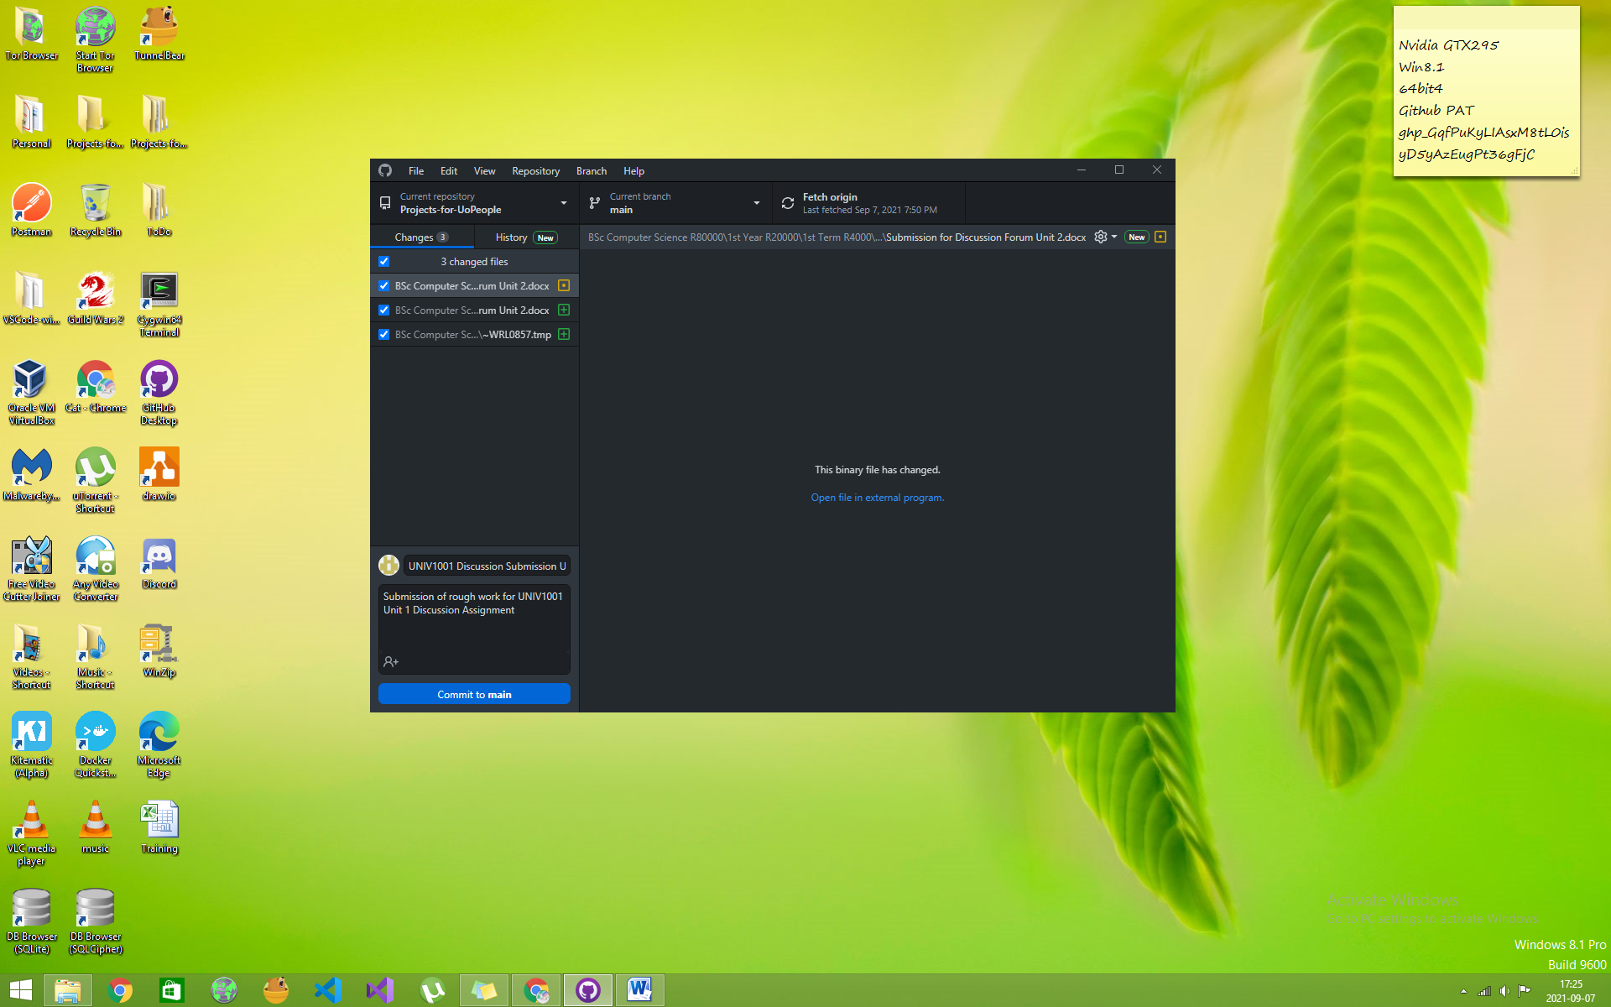

Word Count ()